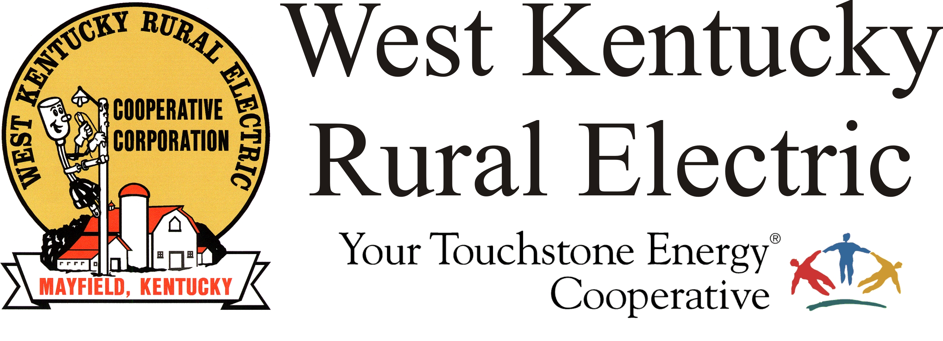

West Kentucky RECC Sunday Morning
Storm Damage Update

(Mayfield, Ky.) Dec. 12, 2021 (9:00 a.m.) – Crews worked overnight repairing some of the serious damage in Graves and Marshall counties. Today we have crews in from Jackson Purchase Energy, Cumberland Valley Electric and Licking Valley Electric. We expect several more crews to arrive from Mississippi this afternoon.

We continue to have about 30,000 meters without service.

We are still waiting for TVA to restore power to our substations. They are repairing and replacing several of the huge transmission structures that carry the power to our area. We had hoped to see the first of these come online last night, but they encountered problems that caused delays. We are working closely with TVA to promote safe, quick repairs.

To understand the challenges of transmission, imagine that your car has been having problems with the carburetor. You want to take it to the shop for repairs, but when you go out, you find the battery is dead. You can’t go anywhere until you fix the battery. So we are doing our best to repair the carburetor while we wait to get a new battery.

Those members near the path of the tornado can expect to be without power for several more days. We understand this is frustrating, but we are in the middle of the largest natural disaster to strike our region. In many ways, it is just as devastating as the 2009 ice storm.

Our crews and contractors will continue working 24/7 on staggered schedules.

We continue to struggle with phone and internet availability due to regional outages. Our website and outage map are both inaccessible.

Please stay away from downed power lines and stay off the roads. Line crews and first responders are having trouble reaching their destinations due to heavy traffic.

Anyone with electricity-dependent medical devices or other health concerns should arrange to relocate or secure a generator. for an alternate power source. Please take steps to make sure your family is safe.

###

Georgann Lookofsky
270-804-1701
glookofsky@wkrecc.com

